Exercises Biol-480 – Neuroanatomy (13/09/2024)

General Questions
- The Central Nervous System (CNS) includes the brain and spinal cord, while the Peripheral Nervous System (PNS) consists of 12 cranial nerves and 31 pairs of spinal nerves and is divided into the somatic and autonomic systems.

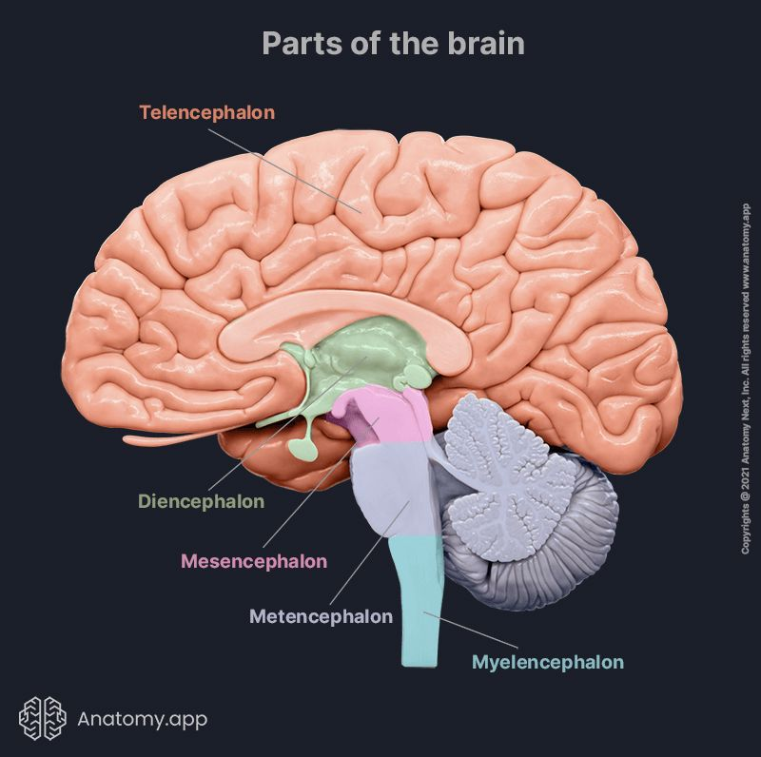

Case studies

Case 1

- This is a horizontal section of the brain.
- The ventricles appear enlarged.
- Note that in patients with brain atrophy, both the sulci and the ventricles are proportionately increased in size. In hydrocephalus, however, the ventricles are increased out of proportion to the amount of sulcal prominence. In our patient the sulci are slightly prominent, while the ventricles are markedly enlarged, making this as a case of hydrocephalus, rather than a neurodegenerative disease.

Case 2

- The reticular formation, located in the myencephalon (medulla) and extending into the metencephalon (pons), is likely damaged.
- The Reticular Activating System (RAS), which is part of the reticular formation, controls wakefulness, alertness, and consciousness.

Case 3

- Schizophrenia
- The substantia nigra in the mesencephalon (midbrain) is implicated in schizophrenia. This area is part of the brain's dopamine system, which plays a crucial role in regulating mood, cognition, and motor control. Dysfunction in this system can lead to the disorganized thinking and erratic behavior typical of schizophrenia.
- The temporal lobe, particularly the auditory cortex, is involved in processing sound. Abnormal activity in this area, often seen in patients with schizophrenia, can lead to auditory hallucinations, as the brain misinterprets internal thoughts as external voices.

